P
Sunday | Monday | Tuesday | Wednesday | Thursday | Friday | Saturday
 |  |  |  |  | 1  HS Regional FB  @ Plainville  vs. Inman  7:00 pm | 2  KMEA @ Hays  for Middle School
3  Daylight Savings Time Ends | 4  Dental Screening  HS League Vocal Clinic @ Osborne  NHS Scholars Bowl  @ Stockton | 5  Dental Screening  NHS Scholars Bowl  @ Lincoln  Election Day! | 6  Dental Screening | 7  Picture Retake Day!  PJH BB @ Chase  4:00 pm | 8  HS FB – Regional  TBA | 9
10  HS Buffer Week | 11  Veterans Salute in the NES Gym 10:15 am  PJH BB @ home  vs. Otis-Bison  4:00 pm  HS Buffer Week | 12  HS Buffer Week | 13  FFA Food Science &  Milk Quality @ Logan  9:00 am  HS Buffer Week | 14  PJH BB @ Stockton  4:00 pm  NHS Scholars Bowl  @ Sylvan 4:30 pm  HS Buffer Week | 15  Teacher Inservice Day  HS FB - Sectionals  TBA  HS Buffer Week | 16  HS Buffer Week
17 | 18  PJH BB @ Rock Hills  4:00 pm | 19  NHS JV Scholars Bowl  @ Palco  4:30 pm | 20  FFA Vet Science &  Farm Business  @ Wakeeney  9:00 am | 21  PJH BB @ home  vs. Lakeside  4:00 pm | 22  HS FB – Substate  TBA | 23
24 | 25 | 26  Career Fair  NHS Scholars Bowl  @ Natoma  4:30 pm | 27  No School!  Thanksgiving Break! | 28  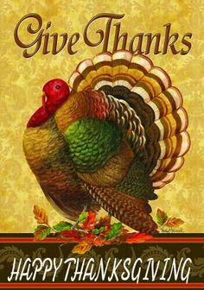 | 29  No School!  Thanksgiving Break! | 30  HS State FB  TBA

November Activities 2024 at USD #399

P[p[p[p[p[-[ppppppppppp=-[p;p’;p[;’[p’;[[-p’;lp[-p;lp-[p’;.,p[;;;’

